ASSIGNMENT ON STEP FUNCTIONS

Ques-Create a step function with the below states:

1. Starting state -> a pass type state with user input as ‘start’, or ‘stop’ or ‘terminate’ or ‘exit’
2. Choice state -> 3 choices : Based on the input value, it will execute 3 lambda functions (start ec2 lambda, stop ec2 lambda, terminate ec2 lambda).
3. Also add a fail state which will be executed if you enter ‘exit’ in your input json.
4. End state

Sol-

Steps to create the step functions:

Step 1 First of all, launch an ec2 instance with given role

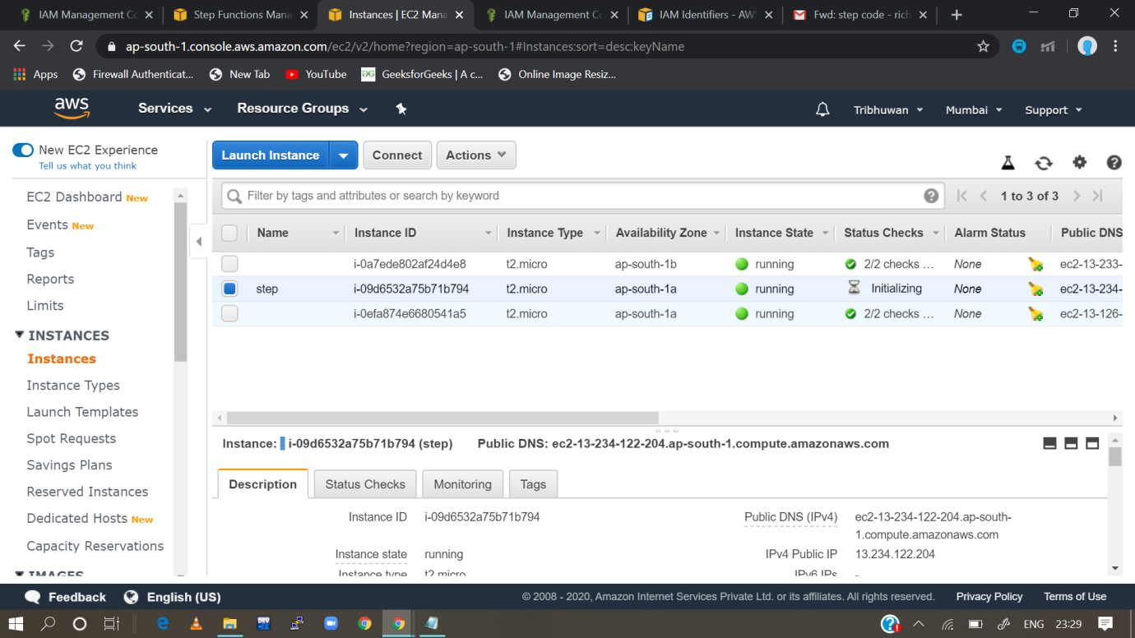

Step 2 Then go to step functions

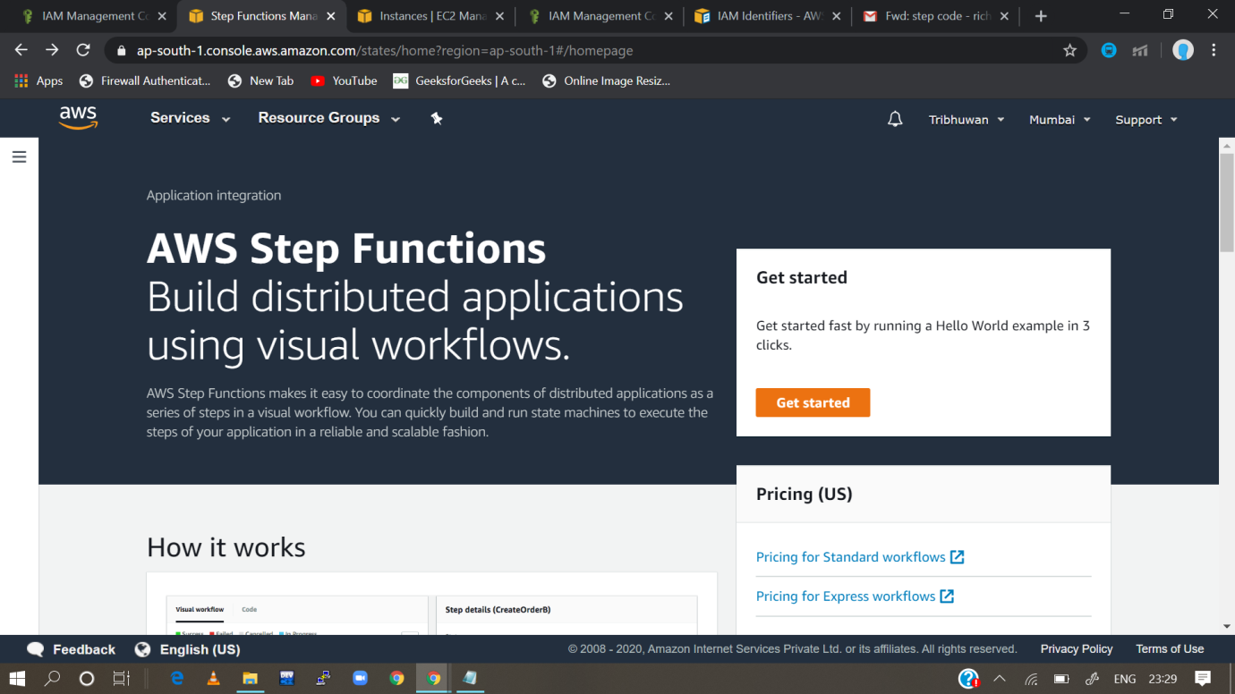

Step 3 Then go to state machine

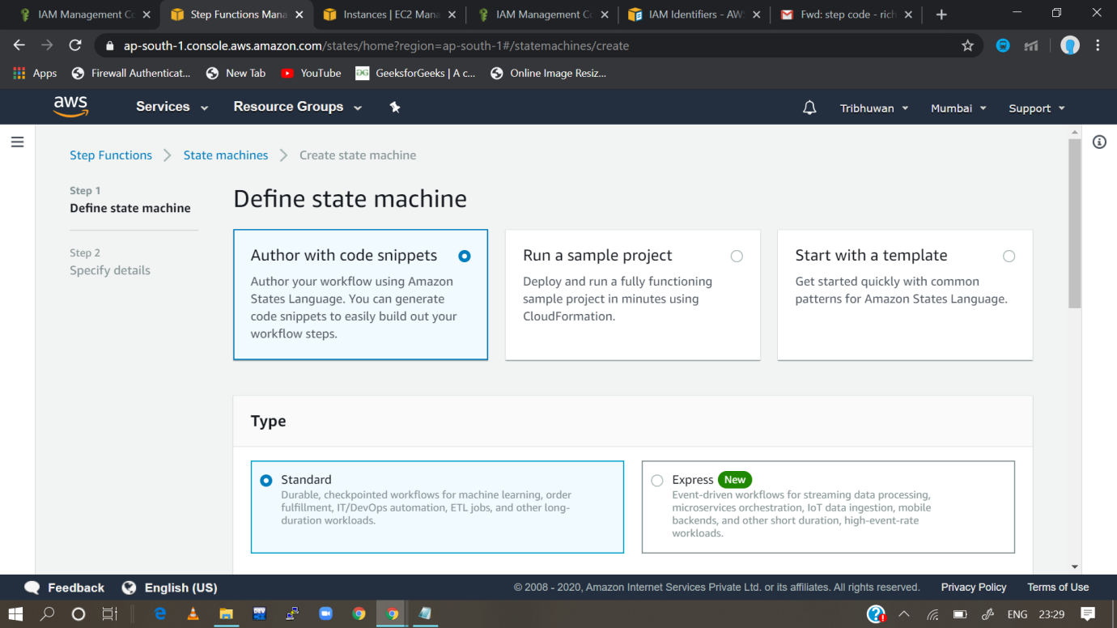

Step 4 Now generate the code snippet

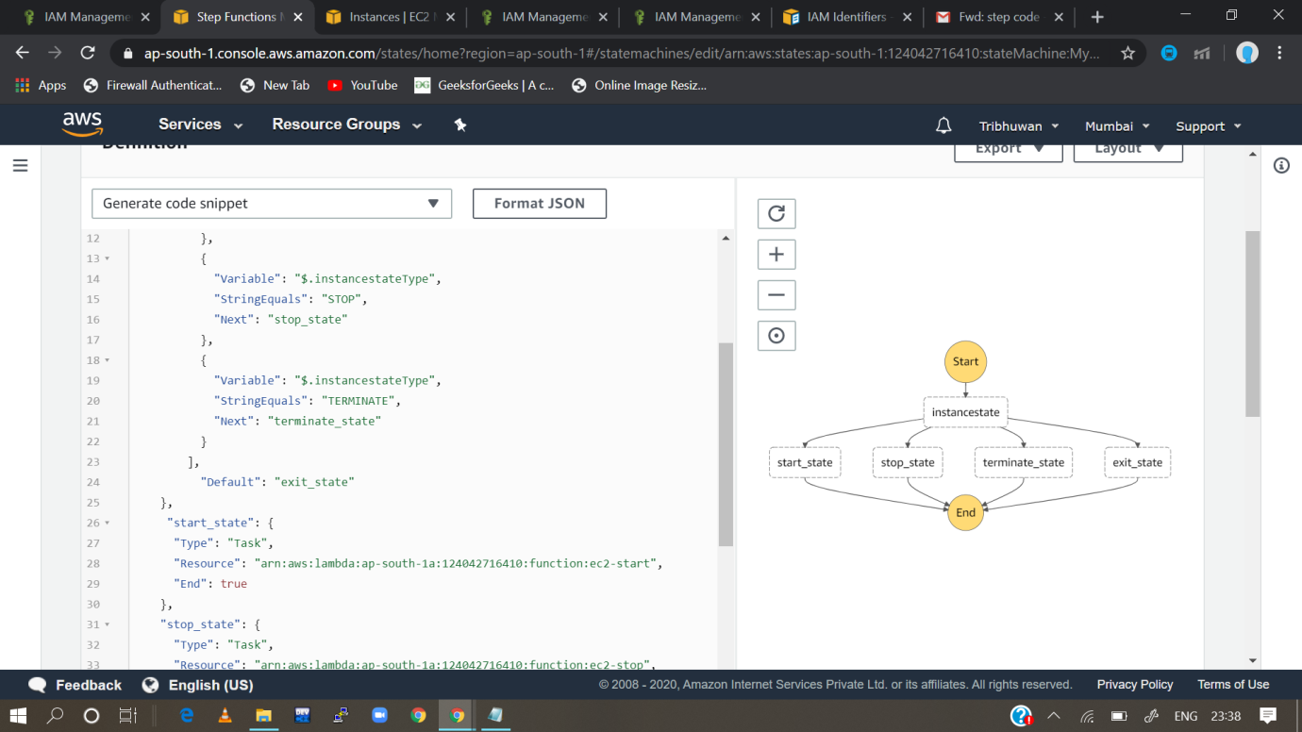

Step 5 Now the state machine successfully created

